

Como Secondary College

2020 Year 11 ATAR ENGLISH

Course Outline

Teaching Team:
J. Armstrong (HoLA)
A. Demonthenous
J.Lindsay



Rationale
The English ATAR course focuses on developing students’ analytical, creative, and critical thinking and communication skills in all language modes. It encourages students to critically engage with texts from their contemporary world, with texts from the past and with texts from Australian and other cultures. Such engagement helps students develop a sense of themselves, their world and their place in it.
Through close study and wide reading, viewing and listening, students develop the ability to analyse and evaluate the purpose, stylistic qualities and conventions of texts and enjoy creating their own imaginative, interpretive, persuasive and analytical responses. The English ATAR course is designed to develop students’ facility with all types of texts and language modes and to foster an appreciation of the value of English for lifelong learning.
Students refine their skills across all language modes by engaging critically and creatively with texts. They learn to speak and write fluently in a range of contexts and to create a range of text forms. They hone their oral communication skills through discussion, debate and argument, in a range of formal and informal situations.

Aims
All senior secondary English courses aim to develop students’:
- skills in listening, speaking, reading, viewing and writing
- capacity to create texts for a range of purposes, audiences and contexts
- understanding and appreciation of different uses of language.
In addition, the English ATAR course aims to develop students’ ability to:
- understand the use of language for communication
- analyse, evaluate and create sustained imaginative, interpretive and persuasive texts in a range of modes
- engage in critical analysis and evaluation.

This course was prepared using one of the Sample Course Outlines supplied by the Schools Curriculum and Standards Authority, modified and adapted to meet the needs of the students of Leeming Senior High School

The information within the document is copyrighted by SCSA and adapted under the allowances published.

Organisation
This course is organised into a Year 11 syllabus and a Year 12 syllabus. The cognitive complexity of the syllabus content increases from Year 11 to Year 12.

Structure of the syllabus
The Year 11 syllabus is divided into two units, each of one semester duration, which are typically delivered as a pair. The notional time for each unit is 55 class contact hours.

Unit 1
Students explore how meaning is communicated through the relationships between language, text, purpose, context and audience. This includes how language and texts are shaped by their purpose, the audiences for whom they are intended, and the contexts in which they are created and received. Through responding to and creating texts, students consider how language, structure and conventions operate in a variety of imaginative, interpretive and persuasive texts. Study in this unit focuses on the similarities and differences between texts and how visual elements combine with spoken and written elements to create meaning. Students develop an understanding of stylistic features and apply skills of analysis and creativity. They are able to respond to texts in a variety of ways, creating their own texts, and reflecting on their own learning.

Unit 2
Students analyse the representation of ideas, attitudes and voices in texts to consider how texts represent the world and human experience. Analysis of how language and structural choices shape perspectives in and for a range of contexts is central to this unit. By responding to and creating texts in different modes and media, students consider the interplay of imaginative, interpretive, persuasive and analytical elements in a range of texts and present their own analyses. Students critically examine the effect of stylistic choices and the ways in which these choices position audiences for particular purposes, revealing and/or shaping attitudes, values and perspectives. Through the creation of their own texts, students are encouraged to reflect on their language choices and consider why they have represented ideas in particular ways.
Each unit includes:
- a unit description – a short description of the focus of the unit
- learning outcomes – a set of statements describing the learning expected as a result of studying the unit
- unit content – the content to be taught and learned.

Organisation of content
Content descriptions in each unit in the English ATAR course are grouped under an organising framework consisting of:
- texts in contexts
- language and textual analysis
- engaging and responding
- creating texts
- reflecting.

Course outline

English – ATAR Year 11

These units have been programmed over 30 weeks to provide assessment options. While unit content dot points are generally identified only once in the Syllabus content column below, many are covered more than once. Opportunities exist across this teaching and learning program for teachers to incorporate general capabilities and cross-curriculum priorities.

Semester 1
Week | Key teaching points | Syllabus content | Assessment tasks
T1 Wk 1 | Unit 1 overview  - Task expectations  - Study expectations  Written and oral communication standards | - Rationale  - Aims  - Organisation  - Grade descriptions  - Glossary  Assessment outline | Students should start reading The Book Thief at the beginning of T1
T1 Wk 2 - 3 | Through the close study of one text or text extract  (e.g. short story, feature article, memoir extract), consider how meaning is shaped through the relationships between language, text, purpose, context and audience.  Interpretive Print texts include:  I Don’t Own Anyone My Body Kirsten King  All the Other Harvey Weinsteins Molly Ringwald  Confessions of a Secret Muslim Sarah Harvard  The Problem with Boys Will Be Boys Tim Winton  Eight Ways I’ve Been Made to Feel About My Asian Eyes Robin Wong  We Should All Be Feminists Chimamanda Ngozi Adichie  Ideological critiques:  Religious Hegemony  Patriarchal hegemony  Feminist theories | Investigate the relationships between language, context and meaning by:  - explaining how texts are created in and for different contexts  - analysing how language choices are made for different purposes and in different contexts.  Examine the language, structure and features of one imaginative, interpretive or persuasive text, including:  - explaining the ways language features, text structures and conventions communicate ideas and perspectives  explaining the ways text structures, language features and stylistic choices are used. | Task 1 Due T1 Week 3  (5%)  In-class Responding  Answer three short answer questions taken from Yr 11 past papers
T1 Wk 3-4 | Composing interpretive texts  Through comparison of the similarities and differences in a variety of texts explored in class, consider how visual, spoken and written language features and conventions shape audience response. Students consider the purpose of texts and how knowledge of context can influence meaning.  Extend the study of Interpretive texts by practicing and creating an interpretive piece in a genre of the students’ choice.  - Revise a good range of stylistic devices, including language, used to interpret the world around you in a highly engaging, informative and persuasive manner  - Understand the range of genres which can be adopted for interpretive writing  - Practise strengthening personal voice in writing  Extracts of students’ material from The Good Answers Guide 2019 will be used as A grade models of interpretive writing | Examine the language, structure and features of imaginative, interpretive and persuasive texts, including:  • explaining the ways language features, text structures and conventions communicate ideas and perspectives  • explaining the ways text structures, language features and stylistic choices are used in different types of texts  • analysing how vocabulary, idiom and rhetoric are used for different purposes and contexts  • evaluating the impact of description and imagery  • evaluating the choice of mode and medium in shaping the response of audiences, including digital texts.  Analyse and evaluate how responses to texts, including students’ own responses, are influenced by:  • the use of techniques associated with imaginative, interpretive and persuasive texts.  Reflecting on their own and others’ texts  • investigating the impact and uses of imaginative, interpretive and persuasive texts. | Task 2 Due T1 Week 4  (5%)  In-class Creating  From a choice of three questions from previous exams, complete an interpretive piece of writing in the genre of your choice.
T1 Wk 5 - 10 | Novel study  Focus on an extended imaginative, interpretive or persuasive text, analysing the relationship between purpose, context and audience and how these relationships influences a text and its meaning; investigate how text structures and language features communicate ideas and represent people and events in a text. (Consider  cross-curriculum priorities and contemporary issues which students face in a globalised world.)  Researching the context of a text and author of choice to discuss how understandings of this text have been influenced by contextual factors  The Book Thief Marcus Zusak  Extracts from The Book Thief film  Extracts from WW2 documentaries | Create a range of texts:  - using appropriate form, content, style and tone for different purposes and audiences in real and imagined contexts  - using evidence-based argument  - using appropriate quotation and referencing protocols  using strategies for planning, drafting, editing and proofreading.  Analyse and evaluate how responses to texts, including students’ own responses, are influenced by:  - purpose, taking into account that a text’s purpose is often open to debate  - personal, social and cultural context  - the use of techniques associated with imaginative, interpretive and persuasive texts. | Task 3 Due: T1 Week 8  (10%)  Creating: Oral presentation  Present an analysis of a theme, character, or integral event from the novel through a PowerPoint of no more than 5 minutes  Task 4 Due T1 Week 10  (10%)  Responding in-class essay  Respond to one analytical essay question from a selection of 6 taken from past papers
T2  Wk 1-3 | Still image analysis  Through comparison of the similarities and differences in a variety of texts explored in class, consider how visual and written language features and conventions shape audience response. Students consider the purpose of texts and how knowledge of context can influence meaning. (Opportunity exists to study texts set or created in different cultural contexts.)  Revision of the devices used to construct a range of visual still images which have been created for a range of purposes: advertising, interpreting, informing, exposing, entertaining | Compare texts in a variety of contexts, media and modes by:  - explaining the relationship between purpose and context  - analysing the style and structure of texts.  Analyse and evaluate how responses to texts, including students’ own responses, are influenced by:  - purpose, taking into account that a text’s purpose is often open to debate  - personal, social and cultural context  - the use of techniques associated with imaginative, interpretive and persuasive texts. | Task 5 Due: T2 Week 3  (5%)  In-class Responding short answers:  Students will complete three short answer responses on three still images (exam preparation)
T2 Wk 4 | Revision and exam preparation | 2019 Good Answers | Non-assessment week
T2  Wk 5-6 | Semester 1 examination | ETA paper | Task 6  Semester 1 examination  (10%)
T2  Wk 7-T3 Wk 3 | UNIT 2 overview  In Unit 2 students consider how ideas, attitudes and voices are represented in texts and how language and structural choices shape perspectives. Students consider the interplay of imaginative, interpretive and persuasive elements in a range of texts and create texts for different purposes, contexts and audiences.  Creating Narrative texts  Creating controlled flash fiction which follows the form of  - a structural narrative: Orientation, Complication, Climax, Resolution.  - Limited time frame, limited number of characters and a limited setting  - Focuses on a strong narrative voice  - Understand basic plots and practise applying techniques in own writing  Students will read and deconstruct a range of short stories and flash fiction, and improve the fluency of their own through practicing the skill for a number of stimuli | Investigate the representation of ideas, attitudes and voices in texts, including:  - analysing the ways language features, text structures and stylistic choices shape perspectives and interpretations  Create a range of texts:  using appropriate form, content, style and tone for different purposes and audiences in real and imagined contexts  - using strategies for planning, drafting, editing and proofreading under timed conditions | Students will need to start reading The Longest Memory at the start of this term  Task 7 Due: T3 week 3  In class: Composing a short story  (15%)  Composing a short story (700 words) based on choice of three questions (taken from past papers)
T3 Wk 3-6 | Film study  Revise filmic techniques and their intended effects on an audience. Revise the connections between audience, context, purpose and genre  Study a film which challenges a society’s perspective on inequality:  Hidden Figures  To Kill a Mockingbird  Jasper Jones  The Help  The Colour Purple  Rabbit Proof Fence  Ideological critiques:  Racial Hegemony  Nationalism  Patriarchal hegemony  Feminist theory | Compare texts in a variety of contexts, media and modes by:  - explaining the relationship between purpose and context  - analysing the style and structure of texts.  Investigate the representation of ideas, attitudes and voices in texts, including:  - genre theory as applied to films  - analysing the ways language features, text structures and stylistic choices shape perspectives and interpretations  - analysing the effects of using multimodal and digital conventions  analysing how attitude and mood are shaped. | Task 8 Due T3 Week 6  Creating Persuasive speech based on one of the themes from a studied film  (10%)
T3 Wk 6 - T4  Wk 4 | Studying a hybrid text The Longest Memory  Study an extended text (such as a novel, a hybrid text,  e.g. graphic novel, biography, autobiography, play, feature film, documentary, a website) to determine how texts represent the world and human experience.  Critically examine the effect of stylistic choices in texts and the ways in which these choices position audiences for particular purposes, revealing and/or shaping attitudes, values and perspectives.  - Introducing students to poststructuralism  - Kantian ethics  - Maslow’s Hierarchy of Needs | Investigate the representation of ideas, attitudes and voices in texts, including:  - How various interpretations of ideas and experiences portrayed in a text leads to discourse  - analysing the ways language features, text structures and stylistic choices shape perspectives and interpretations  - evaluating the effects of rhetorical devices  - analysing the effects of using multimodal and digital conventions. | Task 9 Due T4 Week 4  Responding In-class analytical essay  (10%)  Respond to one analytical essay question from a selection of 6 taken from past papers
T4 Wk 5-6 | Non-assessment week  Yr 11 Exam prep session  Teachers available for additional help, 3-4pm | Using own study notes and past exam questions
Term 4  Week 5-6 | Semester 2 examination | ETA paper | Task 10 Examination: 20%

Como Secondary College

Assessment Outline: 2020 11 ATAR English

Course: English

Unit: ATENG

 |  |  |  | Task Marks
 | Task Description and Content |  | When | Max Score |  | % Weight
 | T1 Responding: In-class 3 short answer responses |  | Term 1 Week 3 | 30.0 |  | 5
 | T2 Creating: In-class Interpretive writing |  | Term 1 Week 5 | 30.0 |  | 5
 | T3 Creating: multimodal presentations |  | Term 1 Week 8 | 30.0 |  | 10
 | T4 Responding: In-class essay on the novel studied |  | Term 1 Week 10 | 40.0 |  | 10
 | T5 Responding: in-class 3 short answers on still images |  | Term 2 Week 3 | 30.0 |  | 5
 | T6 Examination (School Examination)  Semester 1 Examination |  | Term 2 Week 5-6 | 100.0 |  | 10
 | T7 Creating: In-class Narrative writing |  | Term 3 Week 3 | 30.0 |  | 10
 | T8 Creating: Persuasive or Interpretive composition based on the themes from the film |  | Term 3 Week 6 | 30.0 |  | 10
 | T9 Responding: In-class essay on the hybrid text studied |  | Term 4 Week 4 | 40.0 |  | 15
 | T10 Examination (School Examination)  Semester 2 Examination |  | Term 4 Week 5-6 | 100.0 |  | 20
 | Total/Cumulative Mark |  |  |  |  | 100.0

Task Type | Syllabus Weightings | Assessment Task Total Weighting
Responding | 35% | 35.0%
Creating | 35% | 35.0%
Examination | 30% | 30.0%

Year 11 ATAR English expectations

- What is reflective learning?

There is a proven link between reflection and deeper learning. Reflective learning is an active process that involves thinking through issues for yourself, asking questions and exploring appropriate information to improve your understanding. It is an idea process for a learning journal.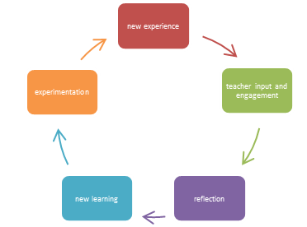

In the contexts of your learning journal, reflection may help you:
- better understand your strengths and weaknesses
- identify and question your values, beliefs and attitudes and/or those of others
- understand the influence of context, audience and purpose on the production of texts and ideas
- acknowledge and challenge the factors on which you base your ideas, thoughts and actions
- recognise and question particular assumptions within society and culture
- appreciate different perspectives and from where it is that they arrive

Ultimately, the reflective process helps you to move from comprehension, to response, to synthesis and then to creation:

- Developing your own personal ‘voice’ when writing

Throughout the year, your teachers be showing you what you need to be doing in your own thinking processes in order to learn. They are offering models of ‘personal voice’, an aspect of response you are required to demonstrate in exam responses. In a similar way to that modelled for you, you need to be considering the ideas in the texts under study, considering how the protagonist’s experiences are like/unlike your own, whether ideas/beliefs/values and attitudes are similar or different, considering the anecdotes of your own lives and considering how this concept is reinforcing or challenging value/beliefs being presented to you. We are working to create cognitive dissonance:
Psychologists have incorporated cognitive dissonance into models of basic processes of learning. Several educational interventions have been designed to foster dissonance in students by increasing their awareness of conflicts between prior beliefs and new information (e.g., by requiring students to defend prior beliefs) and then providing or guiding students to new, correct explanations that resolve the conflicts.
Meta-analytic methods suggest that interventions which provoke cognitive dissonance to achieve directed conceptual change, have been demonstrated across numerous studies to significantly increase learning in science and reading. [https://en.wikipedia.org/wiki/Cognitive_dissonance]
All humans create narratives to develop meaning from our experiences. This course evaluates your ability to develop meaning from your reading and viewing and to integrate this meaning into your own thinking. You will achieve higher marks when you are able to demonstrate you can integrate the concepts into your own thinking, critically examining the world around you and making judgements about what you read/watch/hear using the concepts. This is then demonstrated in your own creative/persuasive writing and argument.

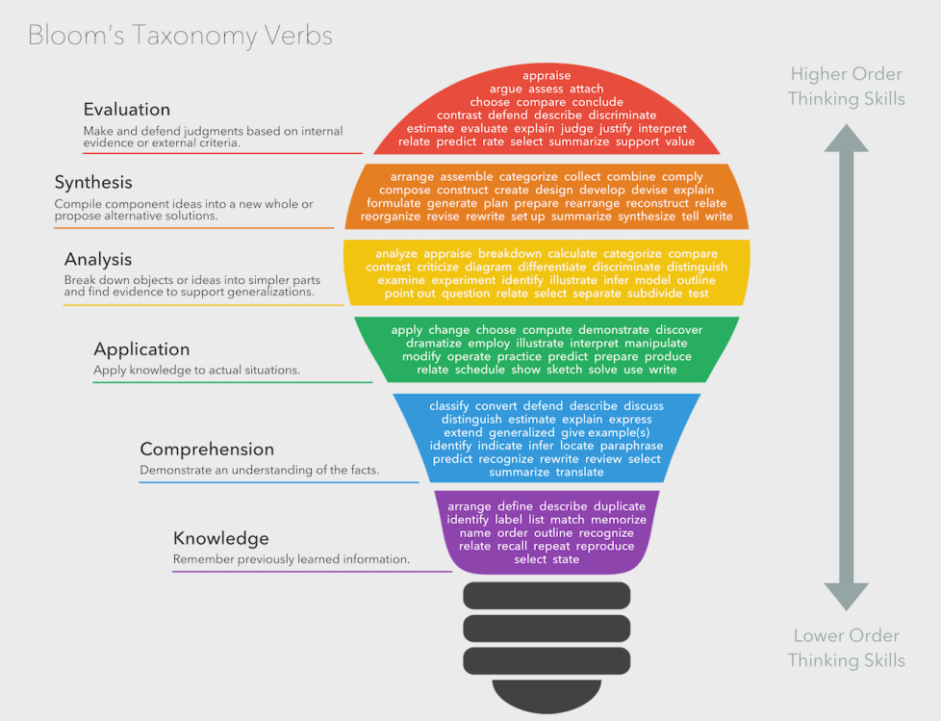

You will be required to
- Ensure that your class notes are up to date and as detailed as possible
- Practise timed persuasive and creative writing (as exam practice)
- Write extended responses to stimuli provided
- Familiarise yourself with glossary definitions and find evidence of these definitions in the texts under study

Develop a partnership with a buddy. Within that partnership, you will
- Comment on the strengths and deficits of the work you have read, using the metalanguage of the syllabus
- Offer suggestions for improvement

During your class time you will find that a great deal of formative assessment will take place. This will take the form of you assessing, and giving feedback to, your peers; ongoing self-assessment; your teacher providing you with ongoing feedback and asking for some from you as the course progresses. This 360 degree feedback process helps you to self-reflect and work through ways to progress your own learning.

- Assessments
The assessment of student learning as described in this document includes both assessment and evaluation:
- verbal or written feedback provided to the student on completed tasks is primarily descriptive and emphasises strengths, identifies solid points of argument and/or weaknesses/challenges, and points to next steps (formative) – this may include correcting students’ errors and comments as appropriate
- assessments will be accompanied by a number (summative) which compares the student’s achievement with standards provided by the Curriculum Council
- the results of this process are communicated to the student [and parents] in writing, either on the task itself, through Connect and through the formal reporting process

with the result that:
- a judgment is made on the basis of a student’s performance against a standards rubric
- this will occur after a standardised process of measurement of a student’s varying levels of comprehension and application of the concepts taught/learnt, allowing the student to be ranked against their cohort of peers

Understandings:
- to ensure students are provided with numerous opportunities to prepare for the WACE examination conditions, all written assessments have been planned under timed conditions in class
- in pursuit of equity, common tasks will be divided between the teaching team and marked by a number of teachers using the common rubric– following the marking process, some discussion will occur to ensure moderation within the team
- in preparing for the marking/grading process, teachers will be/have been informed by professional development sessions and review of Curriculum Council guidelines.

- Cheating/Plagiarism

These are serious offences. In order to prepare you for the world beyond school, it is important that you respect the intellectual property of others. You cannot use their work/words without giving them credit. The theft of intellectual property will be treated very seriously. In an assignment, the mark awarded will be 0 and your parents will be notified. You may be offered the opportunity to re-do the task if it can be arranged considering very tight deadlines in Year 11.

In an examination, cheating is unacceptable. Any attempt to communicate with others will be viewed as cheating. The invigilator will report the matter to the English Head of Learning Area, who will negotiate an appropriate response with the School Administration. Your paper will be given a 0 mark, and your parents contacted to discuss the matter.

- Late work

Late work will incur a mark penalty in accordance with the Upper School Assessment Policy. Generally, work that is three days late will incur a 10% penalty per day. Subsequent tardiness will result in increasing percentage penalties. Letters of concern will be issued for students who are constantly late with submission of work or who fail to undertake the assigned journal tasks. Medical certificates are required for non-submission due to sickness.
ALL WORK MUST BE HANDED TO THE CLASSROOM TEACHER BY THE DEADLINE. ELECTRONIC SUBMISSION WILL NOT BE ALLOWED DUE TO THE CHANCE WORK WILL GO ASTRAY. WORK MUST NOT BE HANDED TO A RELIEF TEACHER OR PLACED ON A TEACHER’S DESK.

Late submission of tasks without legitimate reason will be penalised as dictated in the Como Secondary College’s Assessment Policy .

Appendix 1 – Grade descriptions Year 11
A |  | In responding to texts, the student | In creating texts, the student
 | Language, language features, expression and style | Produces articulate, concise and cohesive analysis of the language used, the language features and the stylistic choices in texts. | Controls language and language features for precision, fluency of expression and stylistic effect.
 | Mechanics of grammar, spelling and punctuation | Sustains control of the mechanics of grammar, spelling and punctuation. | Sustains control of the mechanics of grammar, spelling and punctuation.
 | Purpose, audience, genre | Analyses the relationships between purpose, audience and genre. | Controls the relationships between purpose, audience and genre.
 | Structure | Organises analysis within a coherent structure. | Selects and controls an effective structure.
 | Context | Applies an understanding of contexts to comprehend, interpret and evaluate texts. | Integrates an understanding of context to engage audiences.
 | Comparisons of texts | Makes perceptive comparisons of texts.
 | Supporting evidence | Provides pertinent evidence (by way of quotes and/or examples) to enhance analysis.

B |  | In responding to texts, the student | In creating texts, the student
 | Language, language features, expression and style | Produces clearly expressed and logical analysis of the language used and the stylistic choices made in texts. | Uses language and language features for clarity of expression and development of style.
 | Mechanics of grammar, spelling and punctuation | Controls most of the mechanics of grammar, spelling and punctuation. | Controls most of the mechanics of grammar, spelling and punctuation.
 | Purpose, audience, genre | Analyses the purpose, audience and genre. | Applies a clear understanding of purpose, audience and genre.
 | Structure | Organises analysis within a logical structure. | Selects and controls most elements of structure.
 | Context | Applies an understanding of contexts to make meaning(s) of texts. | Uses an understanding of context to engage audiences.
 | Comparisons of texts | Makes meaningful comparisons of texts.
 | Supporting evidence | Provides relevant evidence (by way of quotes and/or examples) to develop and support analysis.

C |  | In responding to texts, the student | In creating texts, the student
 | Language, language features, expression and style | Discusses some language features and stylistic choices using some clear expression. | Uses some language and language features appropriate to purpose and style of expression.
 | Mechanics of grammar, spelling and punctuation | Controls some of the mechanics of grammar, spelling and punctuation. | Controls some of the mechanics of grammar, spelling and punctuation.
 | Purpose, audience, genre | Discusses the purpose, audience and genre. | Uses some understanding of purpose, audience and/or genre.
 | Structure | Provides some structure for the response. | Controls some elements of structure.
 | Context | Demonstrates some understanding of contexts. | Uses some understanding of context to engage audiences.
 | Comparisons of texts | Makes some relevant comparisons of texts.
 | Supporting evidence | Provides some evidence (by way of quotes and/or examples) to support analysis.

D |  | In responding to texts, the student | In creating texts, the student
 | Language, language features, expression and style | Identifies a limited range of language features and clarity of expression is limited. | Uses a limited range of language and/or language features and clarity of expression is limited.
 | Mechanics of grammar, spelling and punctuation | Demonstrates limited control of the mechanics of grammar, spelling and punctuation. | Demonstrates limited control of the mechanics of grammar, spelling and punctuation.
 | Purpose, audience, genre | Identifies the purpose, audience and/or genre. | Demonstrates limited understanding of purpose, audience and/or genre.
 | Structure | Presents ideas within a limited structure. | Provides limited evidence of structure.
 | Context | Demonstrates limited understanding of contexts. | Makes limited connection between context and audience.
 | Comparisons of texts | Makes limited comparisons of texts.
 | Supporting evidence | Provides limited evidence (by way of quotes and/or examples) to support analysis.

E | Does not meet the requirements of a D grade and/or has completed insufficient assessment tasks to be assigned a higher grade.

